Edgar J. González Serrano R00546279

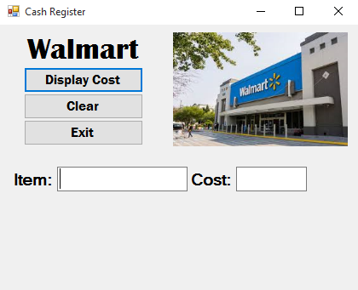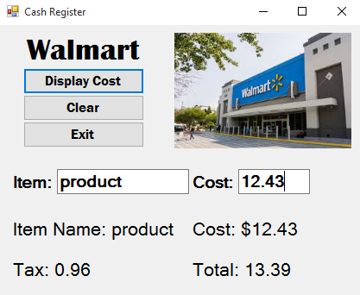

Public Class Form1

Const taxRate As Decimal = 0.0775

Private Sub Calculate_Click(sender As Object, e As EventArgs) Handles Calculate.Click

Dim deccost As Decimal

Dim taxtotal As Decimal

itemname.Text = "Item Name: " & itembox.Text

deccost = Me.costbox.Text

Me.cost.Text = "Cost: $" & Math.Round(Val(deccost), 2)

Me.tax.Text = "Tax: " & Math.Round(Val(costbox.Text * taxRate), 2)

taxtotal = costbox.Text * taxRate

Me.total.Text = "Total: " & Math.Round(Val(deccost + taxtotal), 2)

End Sub

Private Sub Form1_Load(sender As Object, e As EventArgs) Handles MyBase.Load

Me.itemname.Text = " "

Me.cost.Text = " "

Me.total.Text = " "

Me.tax.Text = " "

End Sub

Private Sub BClear_Click(sender As Object, e As EventArgs) Handles BClear.Click

Me.itembox.Text = " "

Me.costbox.Text = " "

Me.itemname.Text = " "

Me.cost.Text = " "

Me.total.Text = " "

Me.tax.Text = " "

End Sub

Private Sub Bexit_Click(sender As Object, e As EventArgs) Handles Bexit.Click

Me.Close()

End Sub

End Class